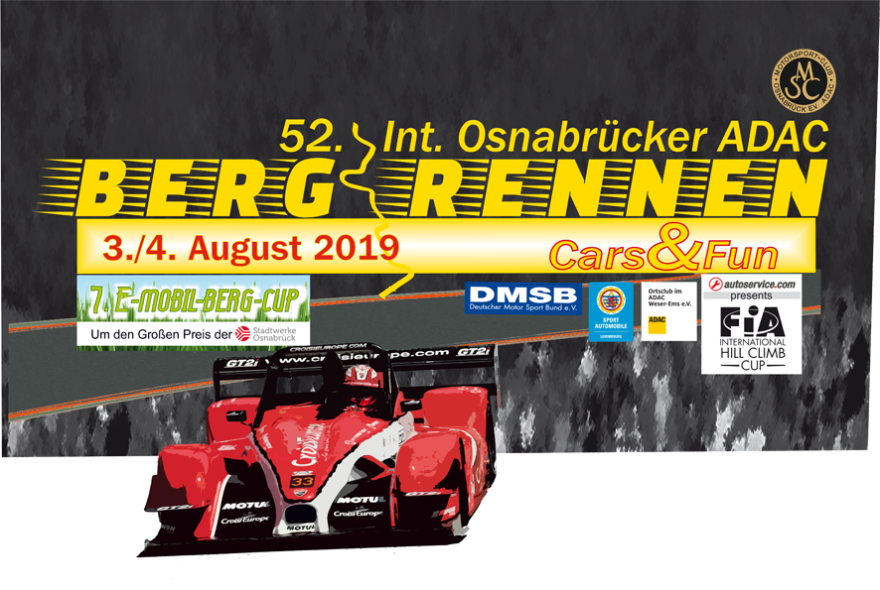

**Media release no. 2**

**Int. 52nd Hill Climb Race Osnabrück:  
a host of highlights at Uphöfener Berg on 3–4 August**

At the Int. 52nd ADAC Hill Climb Race Osnabrück on 3–4 August 2019, **200 drivers from around 15 countries** will be competing on the iconic 2.030 km track of Uphöfener Berg at Hilter-Borgloh south of Osnabrück. The race is the 5th round of the **FIA Int. Hill Climb Cup** and boasts a unique variety of race cars, which spectators will be able to see not only on the race track but also from up close in the paddock.

**Top European sports cars and single-seaters**

Around 40 drivers will populate the categories of single-seaters, two-seater sports cars, Formula 3, Formula 3000 and various single-make formulas.

European hill climb fans are looking forward to seeing the 2018 **European and Italian hill climb champion Christian Merli** (Italy) at his only race in Germany this year. His 2019 season is shaping up to be equally successful, with numerous wins and new track records. He is certainly considered the main pretender for the victory, but there is strong international competition: German-Slovenian **Patrik Zajelsnik** (Norma M20 Mugen V8) clocked a time of under 51 seconds last year, finishing 2nd overall. Other candidates for the podium include the Swiss **Marcel Steiner** (LobArt LA 01), the Austrian **Christoph Lampert** (Osella FA 30), multiple Czech champion **Miloš Beneš** (Osella FA 30) and **Guy Demuth** (Norma M20 FC) from Luxembourg. And if 50.145 seconds track record holder **Sébastien Petit** from France can get hold of a powerful car in time following his accident in Portugal this year, he will also stake his claim to the overall victory. Fans are also eagerly awaiting the return to Uphöfener Berg of the Swiss **Joel Volluz** (Osella FA 30), overall winner in 2015.

Among the Formula 3000 race cars, the Swiss **Robin Faustini** (Reynard K 01) and seasoned reigning Croatian champion **László Szász** from Hungary (Reynard Zytek) are not to be missed.

**Touring car highlights**

The list of touring car highlights is even longer, with nearly all major makes being represented.

One of the high-profile drivers present is **Vidar Jødahl** with his BMW M3 E30, which produces an unbelievable 1,300 hp. The Norwegian’s extravagant driving style delighted the crowds last year, and the YouTube video of his run at Uphöfener Berg has been viewed over 2.5 million times to date.

He will be joined in the paddock by at least another half dozen Norwegian drivers and their attractive touring cars.

Looking at the pretenders for the touring car podium, the first name that comes to mind is that of **Ronnie Bratschi**, reigning FIA Int. Hill Climb Cup touring car champion from Switzerland in his roughly 700 hp Mitsubishi Evo VIII EGMO. He competes against eight times French champion **Nicolas Werver** (Porsche 997 GT2). Local hero Henry Walkenhorst from the Walkenhorst Motorsport professional team will be racing his attractive BMW M6 GT3 and will be bringing other interesting BMW race cars. The French **Philippe Schmitter**’s unique Renault RS 01 and the British **Keith Murray**’s Audi R8 are also expected to meet with considerable fan interest.

German drivers are traditionally strong in the **KW Berg-Cup** with its carefully prepared cars of all relevant makes in all classes.

The race also counts for the **Luxembourg hill climb** **championship**, which will bring drivers of high-powered touring cars to Uphöfener Berg, not least reigning champion **Canio Marchione** with his beautiful BMW 320 STW and the Schilling Performance Team.

The lovingly tended NSU Prinz models in the **NSU Bergpokal** are particularly trusted crowd pleasers, both in the paddock and in their tenacious fights on the track. This is popular motor sports at its best.

The **youngtimer** generation will also be represented by the Fiat Abarth from the “Fight of the dwarfs” series, the BMW 2002 or the Simca Rallye 3, to name but a few.

**Thrill passenger rides**

Several powerful race cars will take passengers on thrill rides along the track, among them McLaren, the Walkenhorst Motorsport BMW Z4 GT3, and a number of gorgeous Porsche models, such as the Porsche Turbo S, Porsche 930 Turbo or Porsche 911.

**Electromobility on the race track**

The **7th E-mobile Hill Climb Cup**, the Stadtwerke Osnabrück Grand Prix at the Int. Osnabrück Hill Climb Race on 3-4 August, will come with a few innovations this year to demonstrate the potential of electric cars and to allow spectators to experience this future-looking technology even more directly.

The large **e-mobile tent**, which hosts the roughly 25 electric and hybrid vehicles, will move closer to the heart of the paddock. Apart from showcasing the cars it will also offer off-track activities for spectators, especially for children, including childcare.

After the press conference on **Friday 2 August** Stadtwerke Osnabrück CEO Christoph Hüls and international hill climb stars are scheduled to line up for a fun test involving an electric kart and a combustion-engine kart, in order to compare the relative performance and acceleration of electric and combustion engines.

**“Cars&Fun” with celebrity guests**

A number of celebrity guests will be at the race, among them triple decathlon world champion and Olympic silver medalist Jürgen Hingsen, TV actor Alexandra Rietz, and TV host, writer and fashion designer Khadra Sufi.

**Livestream on site and on the web**

One of the spectators’ preferred spots is the area by marshal post 5. It offers a fantastic view of the Uphöfener Berg with its particularly challenging sections, and a large LED screen displays live images from along the track.

Fans worldwide can **follow the action online** via livestream on  
[www.msc-osnabrueck.com/livestream/](http://www.msc-osnabrueck.com/livestream/)   
from 9am CEST on Saturday 3 August and Sunday 4 August.

**Timetable**

**Official practice runs** will take place on **Saturday 3 August** from 8am to around 6pm.

The **race heats** are scheduled for **Sunday 4 August** from 8am to around 5pm, followed by the podium ceremony in the large marquee.

**Further information**

You will find all information about the Int. 52nd Hill Climb Race Osnabrück

* on the MSC Osnabrück website [www.msc-osnabrueck.com](http://www.msc-osnabrueck.com)
* on Facebook: <https://www.facebook.com/MSC.Osnabrueck>



* and in the smartphone apps **bergrennen-os** (German) and **OS-Hillclimb** (international)

**Tickets**

**Discounted advance tickets** are available  
under [www.deinticket.de](http://www.deinticket.de) (day passes, family tickets)  
and [www.msc-osnabrueck.com](http://www.msc-osnabrueck.com) (VIP tickets).

